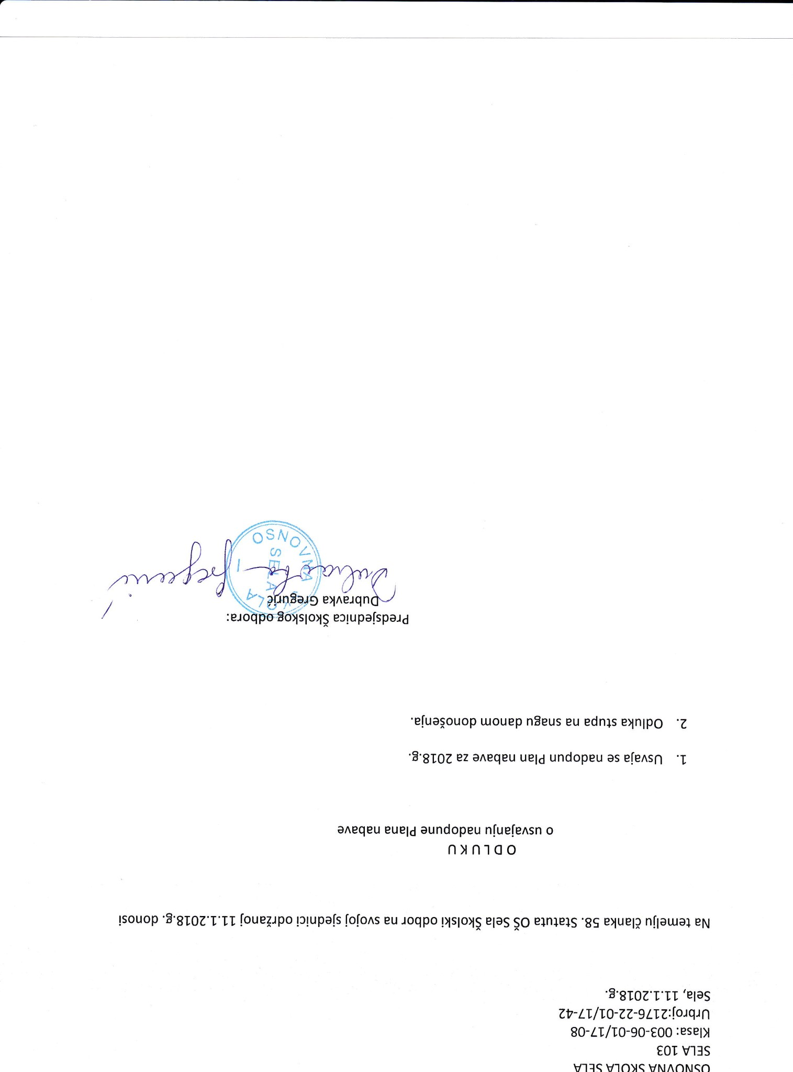

IS

er!upelspard

'efuafouop

r,uouep

n8eus

eu

ednls

eInlpO

'B'A1OZ

ez

aneqeu

ue;6

undopeu

as

efensp

eneqeu

eue16

eundopeu

nfuelensn

o

n)ntco

lsouop

'3'groz'r'tt

foueTrpo

lrlupafs

fofons

Bu

roqpo

llsloli

elas

!

o

e]n]e]s

'8s

eruel?

nfreua]

eN

't'9197'1'11

'ega5

Zn

-

LT

/

T

0-

ZZ-

9

717:[

o

tqt

1

BO-

LT

lT0-90-tOO

:

es

et)

€0r

vlls

Vl1q

V'lO)S

Vt\lAONqo

,z

.I